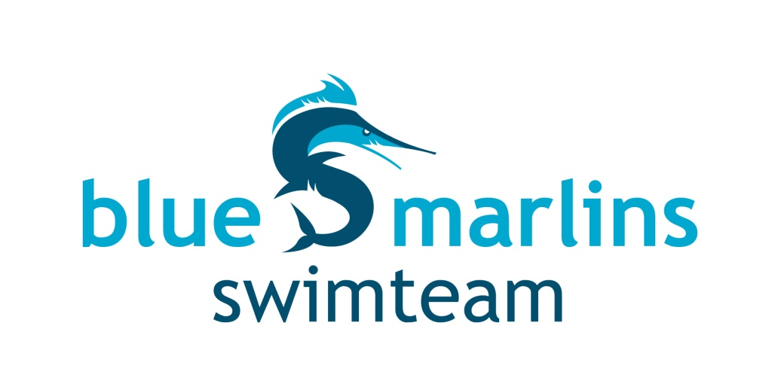

KINGSTON BLUE MARLINS
DISTANCE & DEVELOPMENT CHALLENGE

The Distance & Development Challenge provides shorter events for developing swimmers, and an
opportunity for senior swimmers to check off that distance event they never get a chance to race.

Date: December 2 & 3, 2017 Region: Eastern

Entry Deadline: Tuesday November 21, 2017

Location: Queen’s University Athletics & Recreation Centre, Kingston

Taking place at Queen’s University’s Athletics and Recreation Centre, the 14-lane pool is outfitted with a 7-line Colorado scoreboard, using the Dolphin system for timing. Continuous warm-up and warm-down will be available in three 25-meter lanes separated from the racing pool by a bulkhead.

Summary
Date: Saturday, December 2 – Sunday, December 3, 2017 Region: Eastern
Hosted By: Kingston Blue Marlins
Location: Queen’s University Athletics & Recreation Centre, 284 Earl Street, Kingston
Facility: 14 lane (7 competition lanes), 25m pool with electronic start system.
Warm-up lanes available throughout the meet.
Parking: Available on surrounding streets; underground parking on Division St. at Clergy St. W.
Purpose: The Distance & Development Challenge is an opportunity for development level swimmers to compete in shorter events and a great opportunity for more senior swimmers to compete in some “off” events.
Meet Package: The only meet package which will be considered as valid must be the most current version found on www.swimming.ca.
Competition Coordinator: Cory Cronk, Level IV
Meet Manager: Jackie Decker, jackie.decker@icloud.com
Description: Events will be in a timed final format. The session groups will be mixed, seeded by entry time with the results separated out by age groups (10 & under, 11, 12, 13-14, 15 & over) for the purposes of scoring and awards.
Questions: Contact Jackie Decker: jackie.decker@icloud.com
or Ken Anderson: 613-484-8635 or ken@swimkingston.ca

Competition Rules
Sanctioned by Swim Ontario.
All current Swimming/Natation Canada (SNC) rules will be followed.
Please note that Swimming Canada Competition Warm-Up Safety Procedures will be in effect. The full document can be viewed HERE.
For club and provincial meets, a swimsuit that covers more of the body such as modesty swimwear or religious cover-ups is permitted providing that the fabric is permeable open mesh textile material and does not give the swimmer an advantage. The full interpretation can be viewed HERE. Advanced notification or for clarification of interpretation please see the Competition Coordinator.

Mixed Gender
The host seeks an exemption from the requirement to swim events in gender separated events, on the following basis: due to facility or time limitations, swimming separated by gender would not permit all swims to be completed while offering reasonable opportunities to swim for all participants, and in particular on an equitable basis for swimmers of each gender.
Mixed gender swims may also be permitted when, due to a missed swim, it is necessary for a referee to seed a swimmer in a heat of the same or shorter distance, for competitors of the opposite gender, on an exception basis.
In spite of this rule, any swimmer who achieves a record time at any level (regional, provincial, national etc, whether age group or open) will not be recognized for that record unless the coach has advised the referee prior to the start of the session that there is a possibility of the record being broken, and the referee insures that the swimmer competes with competitors of the same gender for his/her heat.
In the event that mixed gender swims are permitted pursuant to this policy, the results must still be posted separately by the gender of swimmers.

Eligibility
All athletes must be registered as Competitive swimmers with SNC, or any other amateur swimming organization recognized by FINA. A valid SNC registration number is required for all Canadian swimmers, and entries without a SNC registration number will be declined entry.

Entries
Age Up Date: Ages submitted are to be as of December 2, 2017.
Entry Fees: Individual Events: $9.25 per entry
Relays: $12.00 per entry
Please make cheques payable to: Kingston Blue Marlins Inc.
Entries: Entries must be submitted through the SNC online entries system at www.swimming.ca. Meet Management will not accept entries via email.
Online Entry Deadline: November 21, 2017.
All entries must include valid Swim Ontario registration number. Submit entries to Swimming Canada. Once your initial entries are in, minor changes will be accepted after the meet deadline until 3 days before the first day of the meet. After that time, fees will be calculated; no refunds will be granted for missed swims.
Deck Entries: Deck Entries are Exhibition Only. They are not eligible for scoring or awards. Deck entries will be accepted for empty lanes only (no new heats will be created). Swimmers entered on deck must have valid proof of SNC registration (number) as an active, registered, competitive swimmer. $15 per entry
Qualifying Standards: No qualifying times. Please provide swimmer seed times in electronic format.
Event Limit: No event limit.

Schedule of Sessions & Events
See last page.

Coaches’ Registration
Meet management will cross reference the list of coaches in attendance at this competition with the Swim Ontario Compliancy lists. If a coach is not on this list, meet management is obligated to enforce the SNC policy and not permit that coach to attend the meet. Meet management will forward Swim Ontario a list of coaches who they have found to be in non-compliance.

Time Splits
Meet management requires that any coach wishing to rely on a time achieved by the swimmer for an interval shorter than the total distance of the event shall so advise the Referee prior to the commencement of the session (or event) in question.

Notes
Check In and Scratches: There is a positive check in for the 400 IM, 400 Free, 800 Free and 1500 Free.
Scratches are to be made at the clerk of course desk 30 minutes prior to the start of each session.
No substitutions are allowed. Events will not be reseeded.
Awards: Ribbons will be awarded to the top 7 swimmers in each event for each age/gender group as follows: 10 and under, 11, 12, 13 - 14, 15 years and over.
Meet Results: Official Results will be posted within 48 hours of completion of the meet to www.swimming.ca. The meet program will be run on Hy-Tek Meet Manager and results will be posted as quickly as possible at the meet. Live results via Meet Mobile will be available.
Recording of Event: Only individuals that have made application and received authorization to record the event, in any manner, in any medium or context now known or hereafter developed, shall be granted access and permission to do so. Please contact the Meet Manager for application and authorization.
Safety and Liability: Only participating swimmers, officials, certified registered coaches, and authorized people are allowed on deck. Only lap swimming is permitted during the continuous warm-up and warm-down. Horseplay will not be tolerated.

Meet Notes: All mixed groups will be seeded within each session according to entry time. Heat Sheets will be available both electronically and on paper at the meet. Electronic results will be available through Meet Mobile.

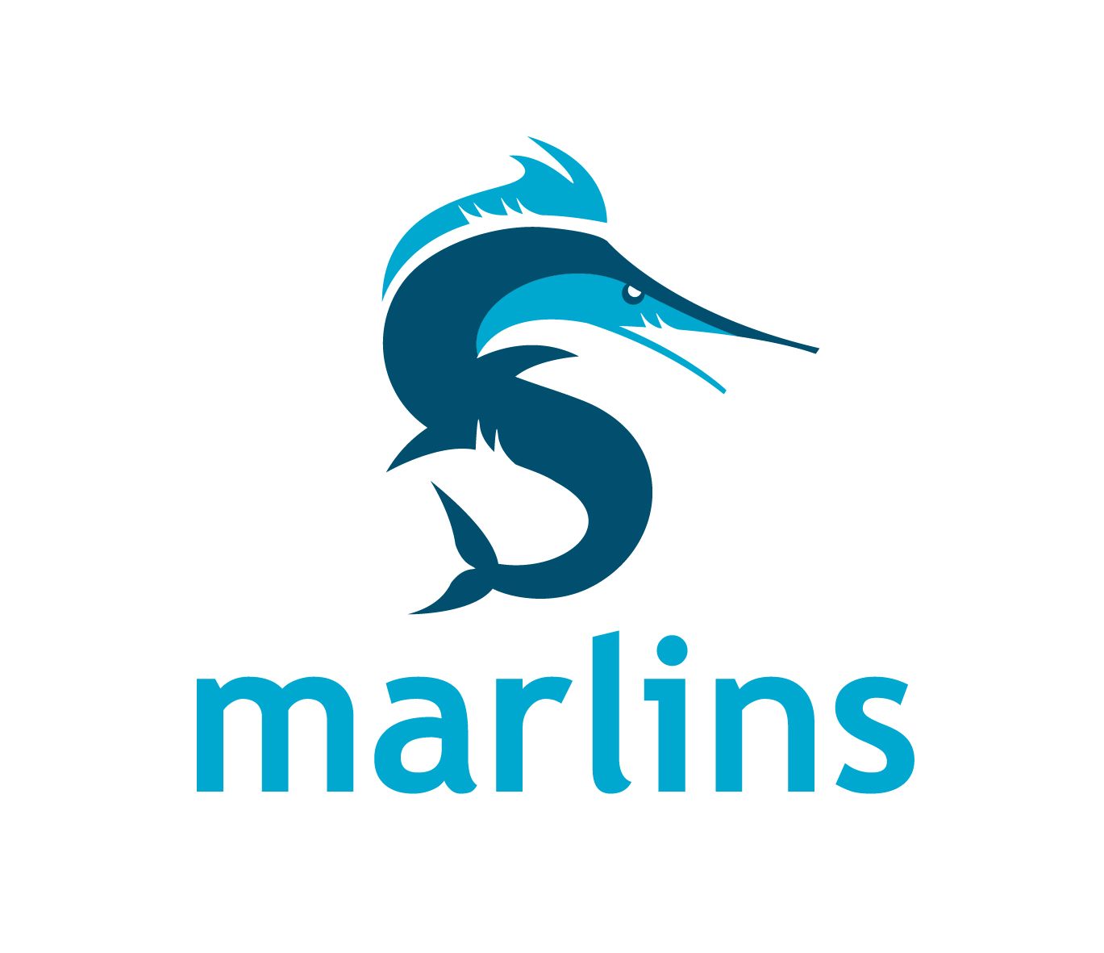
Schedule of Sessions
Sessions
Session | Day | Type | Age Groups | Warm-up | Start | Finish | Estimated  Duration
1 | Saturday | Timed Finals | All Age Groups | 8:00 am | 9:00 am | 11:30 am | 2:30
2 | Saturday | Timed Finals | 12 & under | 11:30 am | 12:15 pm | 2:45 pm | 2:30
3 | Saturday | Timed Finals | 13 & over | 3:00 pm | 4:00 pm | 5:30 pm | 1:30
4 | Sunday | Timed Finals | 12 & under  (Event 25: All Age Groups) | 11:30 am | 12:30 pm | 4:00 pm | 3:30
5 | Sunday | Timed Finals | 13 & over | 4:00 pm | 4:30 pm | 6:00 pm | 1:30

Schedule of Events
Saturday
Session 1: All Age Groups  Warm-up: 8:00 am Start: 9:00 am |  | Session 2: 12 & Under  Warm-up: 11:30 am Start: 12:15 pm
There will be three 25m lanes available for continuous warm-up/warm-down throughout the meet.
Event # | Event | Event # | Event
1 | 400 IM | 4 | 200 IM
2 | 400 Free | 5 | 100 Back
3 | 800 Free  (slowest to fastest due to 12 and under age group swimming next session) | 6 | 50 Breast
 |  | 7 | 100 Fly
 |  | 8 | 100 Free
 |  | 9 | Girls 10 & Under: 4 x 50 Free Relay
 |  | 10 | Boys 10 & Under: 4 x 50 Free Relay
 |  | 11 | Girls 11 & 12: 4 x 50 Free Relay
 |  | 12 | Boys 11 & 12: 4 x 50 Free Relay
Saturday
Session 3: 13 & Over
Warm-up: 3:00 pm Start: 4:00 pm
There will be three 25m lanes available for continuous warm-up/warm-down throughout the meet.
Event # |  | Event
13 |  | 50 Free
14 |  | 50 Fly
15 |  | 200 Fly
16 |  | 100 Breast
17 |  | 50 Back
18 |  | 100 IM

Sunday
Session 4: 12 & Under  Note: Event 25 is for All Age Groups  Warm-up: 11:30 am Start: 12:30 pm |  | Session 5: 13 & Over  Warm-up 4:00 pm Start: 4:30 pm
There will be three 25m lanes available for continuous warm-up/warm-down throughout the meet.
Event # | Event | Event # | Event
19 | 200 Free | 26 | 100 Back
20 | 50 Fly | 27 | 50 Breast
21 | 100 Breast | 28 | 100 Fly
22 | 50 Back | 29 | 200 Breast
23 | 100 IM | 30 | 100 Free
24 | 50 Free | 31 | Girls 13-14: 4 x 50 Free Relay
15 minute break / warm-up |  | 32 | Boys 13-14: 4 x 50 Free Relay
25 | 1500 Free - ALL AGES (fastest to slowest) | 33 | Girls 15 & Over: 4 x 50 Free Relay
 |  | 34 | Boys 15 & Over: 4 x 50 Free Relay

