**Meet Information Package**

**23rd Annual**

**LAC - 12 & Under Celebration**

**January 19-20, 2019**

**London, Ontario**



**23rd Annual**

**LAC - 12 & Under Celebration**

|  |  |  |  |  |  |  |  |  |  |  |  |  |  |
| --- | --- | --- | --- | --- | --- | --- | --- | --- | --- | --- | --- | --- | --- |
|  | | | | | | | | | | | | | |
| **DATE(S):** | | | | | Saturday, January 19 - Sunday, January 20, 2019 | | | | | | | | |
| **HOSTED BY:** | | | | | London Aquatic Club | | | | | | | | |
| **LOCATION:** | | | | | Canada Games Aquatic Centre  1045 Wonderland Road North  London, Ontario N6G 2Y9 (between Gainsborough and Lawson Road) | | | | | | | | |
| **FACILITY:** | | | | | Eight-lane, 50-meter indoor tank, with bulkheads to create two 25-meter pools; with “Keifer” type lane markers; Daktronics 64101-H8 8 lane swimming scoreboard at both ends of pool with Swiss Timing Quantum Aquatic Timing System. | | | | | | | | |
| **PURPOSE:** | | | | | 12 & Under Short Course Invitational | | |  | | | | | |
|  | | | | |  | | |  | | | | | |
| **MEET PACKAGE:** | | | | | The only meet package which will be considered as valid must be the most current version found on [www.swimming.ca](http://www.swimming.ca/). | | | | | | | | |
| **MEET MANAGER:** | | | | | Steve Baarda | | | steve@stevebaarda.com  (519) 878-5566 | | | | | |
| **COMPETITION COORDINATOR:** | | | | | Denise McDonald – Level V | | | mcdonald.denise.e@gmail.com | | | | | |
|  | | | | |  | | |  | | | | | |
| **MINOR OFFICIALS:** | | | | | Rebecca Shearer | | | [rebeccashearer@rogers.com](mailto:rebeccashearer@rogers.com) | | | | | |
| **DESCRIPTION:** | | | | | This is a short course double-ended meet for swimmers 12 & Under. All events are Timed Finals.  All events will be swum slowest to fastest by submitted entry times. | | | | | | | | |
| **COMPETITION RULES:** | | | | | Sanctioned by Swim Ontario  All current Swimming Canada (SC) rules will be followed.  All swimmers participating in a provincially sanctioned meet shall be required to comply with swimwear rule GR 5. Click [HERE](https://swimontario.com/uploads/Officials/Resources/SwimwearRulesGR5_2018.pdf) to view full details. Advanced notification for exemption or for clarification of the rule please see the Competition Coordinator.  Swimming Canada Competition Warm-Up Safety Procedures will be in effect. The full document can be viewed [HERE.](https://www.swimming.ca/en/resources/officiating/event-resources/competition-warm-up-safety-procedures/%20) | | | | | | | | |
| **AGE UP DATE:** | | | | | Age determined as of first day of meet, **Saturday, January 19, 2019**. | | | | | | | | |
| **DIVE STARTS:** | | | | | As per the Facility Rules for Dive Starts, this competition will be conducted as follows:  Starts will be conducted from Starting Platforms (blocks) as per FINA FR 2.3 and SW 4.1   * from deep end AND * from bulkhead position at mid-point in pool into shallow end | | | | | | |
|  | | | | |  | | | | | | |
| **RECORDS:** | | | | | Swim times achieved at this competition will NOT be used for applications of provincial and national records. | | | | | | |
| **ELIGIBILITY:** | | | | | All athletes must be registered as Competitive Swimmers with SC, or any other amateur swimming organization recognized by FINA. A valid SC registration number is required for all Canadian swimmers, and entries without a SC registration number will be declined entry. | | | | | | | | |
| **QUALIFYING/**  **DE-QUALIFYING TIMES:** | | | | | There are no qualifying or de-qualifying times. | | | | | | | | |
| **ENTRY FEES:** | | | | $10.00 per swimmer per individual event.  $14.00 per relay team entry.  (includes HST – London Aquatic Club GST # R103378279) | | | | | | | | |
| **PAYMENT:** | | | | Please submit one cheque for all club swimmers with your entries.  Payable to: **London Aquatic Club** | | | | | | | | |
| **ENTRIES:** | | | | Entries will be at the discretion of the Meet Manager.  All entries must be in a format accepted by Hy-tek Meet Manager and be submitted through the SC online entries system at: [www.swimming.ca](http://www.swimming.ca/).  Meet Management will not accept entries directly via any other means.  Please include appropriate Short Course (in meters) entry times (estimate if necessary – “NT” entries **WILL NOT** be accepted).  Each swimmer must swim in the proper age group. Swimming “up” is only permitted on relays.  **Maximum number of INDIVIDUAL events**:  Swimmers are limited to a maximum of three (3) individual events per session. Relays do not count as an individual event.  Only swimmers aged 11-12 are eligible to swim the 400 IM. Those swimmers may swim the 400 Freestyle or the 400 IM but NOT both. | | | | | | | | |
| **ENTRY DEADLINE:** | | | | Entry Deadline: **Wednesday, January 9, 2019**  **You will be sent confirmation of receipt of your entries.**  **Please ensure that you check these entries and immediately contact the Meet Manager with any problems.** | | | | | | | | |
| **DECK ENTRIES:** | | | | Deck entries may be accepted (as Exhibition Swims) to fill empty lanes or scratched lanes but will not be eligible for awards or prizes in those events. | | | | | | | | |
| **DECK ENTRY FEES:** | | | | $12.00 per swimmer per individual event.  $15.00 per relay team entry.  Payable at the time of the request.  (includes HST – London Aquatic Club GST # R103378279) | | | | | | | | |
| **SCRATCH RULES:** | | | | Scratches can be made at any time. No penalty for scratches or no shows. | | | | | | | | |
| **CONVERSION:** | | | | Any Long Course times submitted will be converted into Short Course times using MM7 default conversion factor. | | | | | | | | |
|  | | | |  | | | | | | | | |
| **AGE CLASSIFICIATIONS:** | | | | Male and female:  Individual: 8 & Under, 9, 10, 11, 12.  Relays: 8 & Under, 9-10, 11-12. | | | | | | | | |
| **PARA:** | | | | PARA swimmers will be officiated under WPS Swimming Rules. | | | | | | | | |
| **MANAGEMENT ITEMS:** | | | | Meet Management reserves the right to split session age categories to ensure proper session lengths. Meet Management reserves the right to limit the number of entries and the number of swimmers in any event.  400 Freestyle Event: The top 16 will swim one per lane, slower heats MAY be swum 2 per lane.  Sprint lanes for the last 20 minutes of warm-ups. Lanes 1 and 8 will be used for Sprinting and are designated as diving lanes. After the dive the swimmer must leave the lane and return to the starting end. PARA and Backstroke start lanes may also be designated, will be announced, and then will be controlled by the Safety Marshals.  Meet officials will provide a safe environment and an organized competition. We are not responsible for the supervision of the athletes during the competition or during session breaks. | | | | | | | | |
| **CANCELLATIONS:** | | | | In the event of unforeseen circumstances beyond the control of the City of London or London Aquatic Club, (for example but not limited to; weather interruptions or facility malfunctions) that force the cancellation of all or part of the meet, a partial refund **may** be granted at the discretion of the Meet Manager. | | | | | | | | |
|  | | | |  | | | | | | | | |
| **COACH'S REGISTRATION:** | | | Meet Management will cross-reference the list of coaches in attendance at this competition with the [Swim Ontario Compliancy lists](http://www.swimontario.com/page.php?id=2748). If a coach is not on this list, Meet Management is obligated to enforce the SC policy and not permit that coach to attend the meet. Management will forward Swim Ontario a list of coaches who they have found to be in non-compliance. | | | | | | | | | |
| **TIME SPLITS:** | | | The procedure for obtaining an 'Official Split' now requires that coaches make the request to the session Referee or Meet Management on a time card (provided by the Meet Office) prior to the race. The split for the lead-off leg in relays will still be regarded as an official split and therefore no request by coaches is needed for relays. However, in the new 'mixed gender' relays, lead-off times/splits are not considered ‘official splits' as per international practice.  **Official Splits:** Meet Management requires that any coach wishing to rely on a time achieved by the swimmer for an interval shorter than the total distance of the event shall so advise the Referee prior to the commencement of the session (or event) in question. **Please note that the coach must provide 3 timers to complete this official split.** | | | | | | | | | |
|  | | |  | | | | | | | | | |
| **AWARDS:** | | | Individual awards: Place Medals 1st through 3rd, Ribbons: 4th through 8th by age classification.  Relay awards: Place Medals 1st through 3rd, Ribbons: 4th through 8th by age classification. | | | | | | | | | |
|  | | |  | | | | | | | | | |
| **MEET RESULTS:** | | | The meet will run on Hy-Tek Meet Manager. Results will be posted on the LAC website [www.londonaquaticclub.ca](http://www.londonaquaticclub.ca) as quickly as possible and uploaded to [www.swimming.ca](http://www.swimmeet.ca) within 48 hours of the completion of the meet.  Unofficial results will also be posted to Meet Mobile following each event. | | | | | | | | | |
| **RECORDING OF THE MEET:**  **SAFETY AND LIABILITY:**  **FOREIGN COMPETITORS:**  **MIXED GENDER:** | | | Only individuals who have made application and received authorization, in advance, to record the event, in any manner, in any medium or context now known or hereafter developed, shall be granted access and permission to do so. Please contact the Meet Manager for application and authorization.  Photographers must obtain authorization from Meet Management before the start of the meet to obtain access to the deck.  Only participating swimmers, officials, certified registered coaches, and authorized people are allowed on deck.  All swimmers and coaches must be duly registered and residents of the governing body for which they are competing. All swimmers and coaches must be in good standing with their respective governing swim body.  All swimmers and coaches must have primary residence within the province /state or country for which they claim registration. Proof of residency may be green card, student ID, driver’s license, college residence or other document as deemed acceptable by Swim Ontario and shall be submitted with the [Proof of Residence and Registration Status form](http://www.swimontario.com/uploads/Clubs/Club%20Operations/Forms/2015-2016/ProofofResidence.pdf) to Swim Ontario no later than 7 days prior to start of competition.  The host seeks an exemption from the requirement to swim events in gender separated events, on the following basis:  Due to facility or time limitations, swimming separated by gender would not permit all swims to be completed while offering reasonable opportunities to swim for all participants, and in particular on an equitable basis for swimmers of each gender.  Mixed gender swims may also be permitted when, due to a missed swim, it is necessary for a Referee to seed a swimmer in a heat of the same or shorter distance, for competitors of the opposite gender, on an exception basis.    In spite of this rule, any swimmer who achieves a record time at any level (regional, provincial, national etc., whether age group or open) will not be recognized for that record unless the coach has advised the Referee prior to the start of the session that there is a possibility of the record being broken, and the Referee ensures that the swimmer competes with competitors of the same gender for his/her heat.  In the event that mixed gender swims are permitted pursuant to this policy, the results must still be posted separately by the gender of swimmers. | | | | | | | | | |
| **DURING THE MEET:** | | | | **Parking & Accommodations**:  Parking and accommodation options will be posted on the LAC website – LAC Hosted Meet –  12 & Under Celebration ( <http://www.londonaquaticclub.ca> ) | | | | | | | | |
|  | | | |  | | | | | | | | |
|  | | | | **Concession**: | | | | | | | | |
|  | | | | A snack bar will be open throughout the meet. | | | | | | | | |
| **SCHEDULE OF SESSIONS:** | | | |  | | | | | | | | |
|  | | | |  | | | | | | | | |
| Session # | Date | | | | Timed Final | Warm Up | | Start | Finish | Estimated Duration | | | |
| 1 | Jan. 19, 2019 | | | | Timed Final | 12:00 noon | | 1:00 pm | 5:00 pm | 4 hrs. | | | |
| 2 | Jan. 19, 2019 | | | | Timed Final | 12:00 noon | | 1:00 pm | 5:00 pm | 4 hrs. | | | |
| 3 | Jan. 20, 2019 | | | | Timed Final | 7:00 am | | 8:00 am | 12:00 noon | 4 hrs. | | | |
| 4 | Jan. 20, 2019 | | | | Timed Final | 7:00 am | | 8:00 am | 12:00 noon | 4 hrs. | | | |

*** **The above schedule is tentative. No session will be longer than 4.5 hours in length**

|  |  |
| --- | --- |
| **SCHEDULE OF EVENTS:** | See Event Listing - Appendix C on Page 8. |

**Appendix A**

**Canada Games Aquatic Centre**

**Event Procedure Policy For:**

**Meet Managers, Officials, Coaches, Athletes & Spectators**

1. The City Of London Aquatic Staff (and specifically the CGAC Deck Supervisor) will remain in control of the facility at all times during the event. Their decisions and instructions are to be complied with without argument by all participants, coaches and officials. In the event of an emergency, City staff will only transfer care of an individual to EMS personnel.
2. No coach or official may permit a swimmer to enter the pool prior to the lifeguards being in place. No swimmer is to enter the pool without lifeguards in place.
3. All participants must obey all pool rules as posted.
4. No outside footwear may be worn on the pool deck by any participant, coach, official or any other person.
5. No food of any kind is permitted on the pool deck, except for refreshments provided directly to officials.
6. Coaches are responsible for the conduct of their team at all times in all areas of the facility.
7. Participants / coaches are responsible for picking up their garbage and depositing it in waste containers; excessive garbage left on the pool deck will be billed as an additional staffing charge.
8. Participants must be dry and wearing footwear on the upper level.
9. Participants / coaches / officials must not leave belongings in front of access points, including but not limited to emergency exits, staff offices, first aid rooms, change rooms, etc.
10. Parking is permitted in designated areas only; parking is not permitted on curbs or on grass areas surrounding the building. Signs will be posted indicating parking locations.

**RZONE**

Rzone is a program requiring all persons wishing to visit or use any City of London recreation facility, park, or program, to respect others and take responsibility in helping the City maintain a positive environment. The "R" in Rzone stands for Respect and Responsibility. Respect for yourself, Respect for others, and Responsibility for your actions. The Rzone program applies to all community organizations and individuals using City of London recreational facilities, parks, and programs.

**Please review the information online at** [**http://london.ca/rzone**](http://london.ca/rzone) **before attending this event.**

**Appendix B**

**City Of London By-Law**

**Single Use Disposable Water Bottles**

According to the City of London by-laws, single use disposable standard water bottles can no longer be sold at events hosted at city-owned facilities.

We will continue with our Maximize Waste Diversion. Water coolers / city water taps will be available for water needs for our Athletes, Coaches, Officials, and Volunteers.

Please make sure that you bring a refillable water bottle with you to our meet.

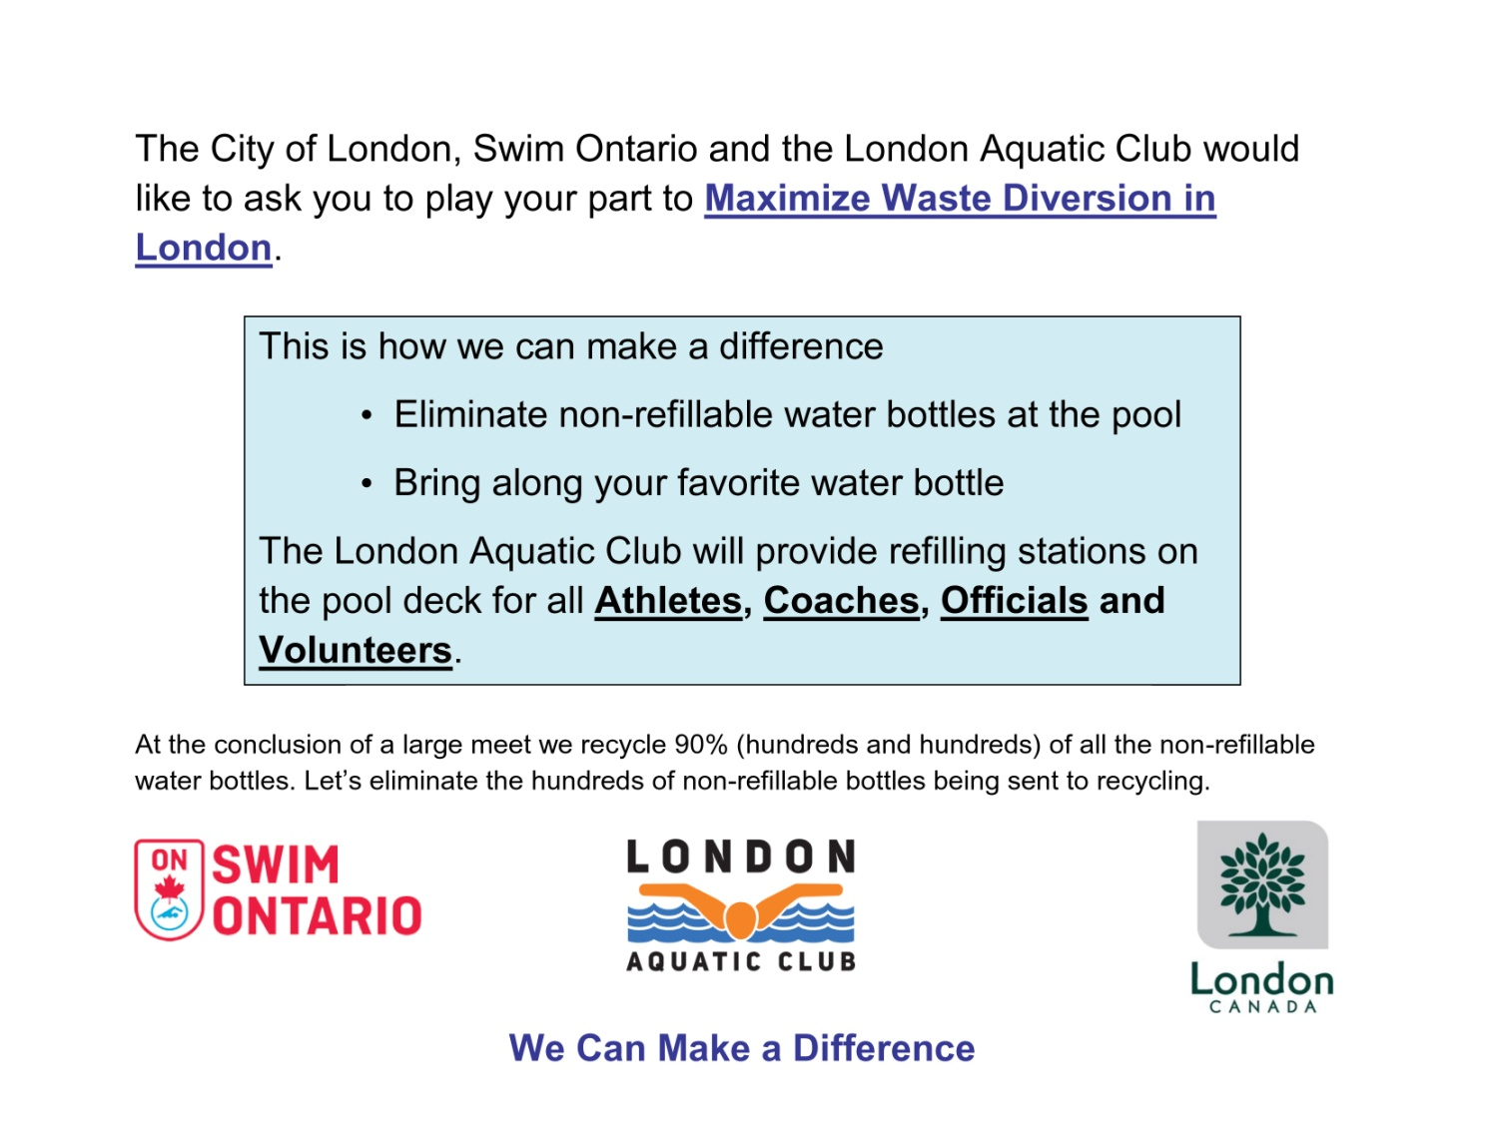

**Appendix C**

**Event Listing:**

|  |  |  |  |  |
| --- | --- | --- | --- | --- |
| **Session 1 & 2 - Timed Finals** | | | | |
| **Saturday Afternoon, January 19, 2019** | | | | |
| **Warm-up ⇒ 12:00 noon Start ⇒ 1:00 p.m. Finish ⇒ 5:00 p.m.** | | | | |
|  |  |  |  |  |
| Gender | Event | | Prelim. / Final | Gender |
| Girls |  |  |  | Boys |
| 1 | 4 X 50 Free Relay | 11 - 12 | Timed Final | 2 |
| 3 | 4 X 50 Free Relay | 9 – 10 | Timed Final | 4 |
| 5 | 4 X 50 Free Relay | 8 & under | Timed Final | 6 |
| 7 | 200 IM | 11 - 12 | Timed Final | 8 |
| 9 | 200 IM | 10 & under | Timed Final | 10 |
| 11 | 50 Back | 11 – 12 | Timed Final | 12 |
| 13 | 50 Back | 10 & under | Timed Final | 14 |
| 15 | 200 Free | 11 – 12 | Timed Final | 16 |
| 17 | 200 Free | 10 & under | Timed Final | 18 |
| 19 | 100 Breast | 11 – 12 | Timed Final | 20 |
| 21 | 100 Breast | 10 & under | Timed Final | 22 |
| 23 | 50 Free | 11 – 12 | Timed Final | 24 |
| 25 | 50 Free | 10 & under | Timed Final | 26 |
| 27 | 200 Back | 11 – 12 | Timed Final | 28 |
| 29 | 200 Back | 10 & under | Timed Final | 30 |
| 31 | 100 Fly | 11 – 12 | Timed Final | 32 |
| 33 | 100 Fly | 10 & under | Timed Final | 34 |

|  |  |  |  |  |
| --- | --- | --- | --- | --- |
| **Session 3 & 4 - Timed Finals** | | | | |
| **Sunday Morning, January 20, 2019** | | | | |
| **Warm-up ⇒ 7:00 a.m. Start ⇒ 8:00 a.m. Finish ⇒ 12:00 noon** | | | | |
|  | | | | |
| Gender | Event | | Prelim. / Final | Gender |
| Girls |  |  |  | Boys |
| 35 | 4 X 50 Md. Relay | 11 - 12 | Timed Final | 36 |
| 37 | 4 X 50 Md. Relay | 9 – 10 | Timed Final | 38 |
| 39 | 4 X 50 Md. Relay | 8 & under | Timed Final | 40 |
| 41 | 200 Fly | 11 - 12 | Timed Final | 42 |
| 43 | 100 Free | 11 - 12 | Timed Final | 44 |
| 45 | 100 Free | 10 & under | Timed Final | 46 |
| 47 | 50 Breast | 11 – 12 | Timed Final | 48 |
| 49 | 50 Breast | 10 & under | Timed Final | 50 |
| 51 | 100 Back | 11 – 12 | Timed Final | 52 |
| 53 | 100 Back | 10 & under | Timed Final | 54 |
| 55 | 50 Fly | 11 – 12 | Timed Final | 56 |
| 57 | 50 Fly | 10 & under | Timed Final | 58 |
| 59 | 200 Breast | 11 – 12 | Timed Final | 60 |
| 61 | 200 Breast | 10 & under | Timed Final | 62 |
| *63 | 400 Free | 11 – 12 | Timed Final | *64 |
| 65 | 400 Free | 10 & under | Timed Final | 66 |
| **\*Age 11 – 12 may swim either 400 IM or 400 Free but not both** | | | | |
| *67 | 400 IM | 11 - 12 | Timed Final | *68 |